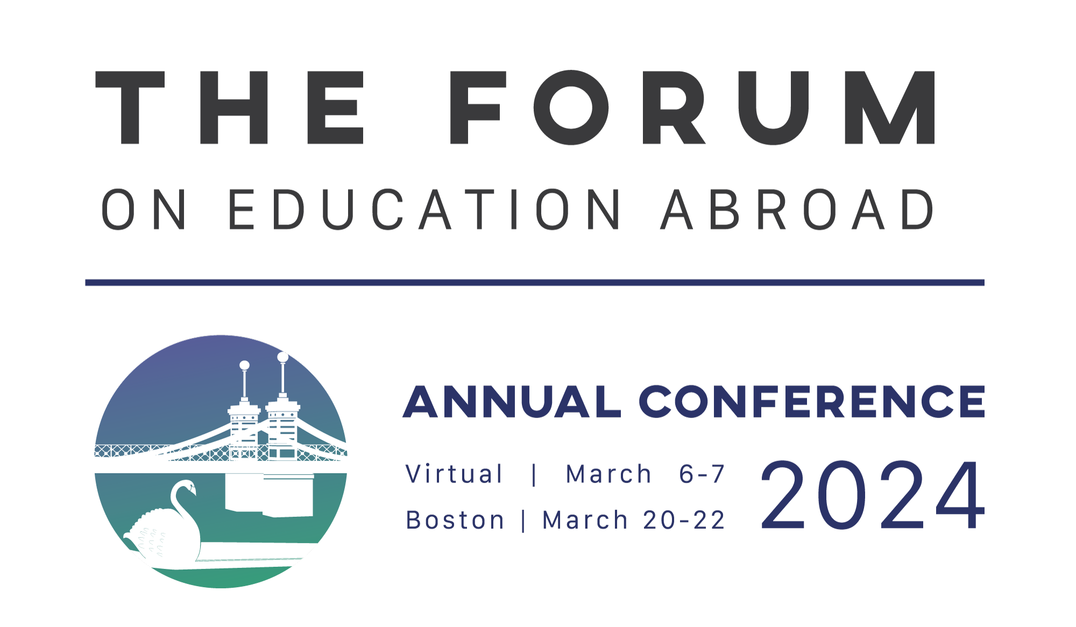

PROPOSAL SUBMISSION TEMPLATE

Important Notes:
- Required steps are noted with a red asterisk (*) and must be completed before submitting your proposal.
- Conference registration costs are the responsibility of each presenter. Presenters must register for the Annual Conference by the early-bird deadline of December 15, 2023.
- Virtual presentations will be recorded. All virtual presenters will be required to consent to grant to The Forum permission to broadcast, reproduce, and distribute the recording and all session materials.
- As part of The Forum’s effort to increase accessibility of conference content for attendees, we will ask that all presenters in accepted proposals 1) submit session materials (slides, handouts, etc.) in advance, and 2) take simple steps to make their session materials accessible (instructions will be provided).
- Presenters defend and hold The Forum on Education Abroad harmless from and against any and all claims, damages, suits, causes of action, liabilities or expenses (including, without limitation, reasonable attorneys' fees) arising from any allegation or claim that their presentation content infringes the intellectual property rights of any third party.

Privacy Policy Consent*
- I consent to allow The Forum on Education Abroad to collect and use the information provided in this form as outlined in their Privacy Policy: https://forumea.org/privacy-policy/

Session Leader Information
- Full Name*
- Email*
- Job Title*
- Affiliation
- Country*
- Pronouns
- LinkedIn Profile
- Short bio (120 words max)

What type of institution/organization are you affiliated with? (select all that apply)
- Public higher education institution
- Private higher education institution
- Community college/Technical, vocational education and training (TVET) institution
- Minority serving institution (MSI), including HBCUs, HSIs, Tribal Colleges & AANAPISIs)
- For profit program provider/education abroad organization
- Nonprofit program provider/education abroad organization
- Professional association or charitable foundation
- Other

Title of proposed session* (75 characters max)

Session Modality* (select one)
- In person session in Boston
- Virtual session
- In person or virtual session, according to The Forum’s needs

Select Your Session Type: (Choose ONE)*
- Panel Presentation (75 minutes in person; 60 minutes virtual): consists of a panel of experts, each approaching the topic/theme from a different perspective, and includes ample time for Q&A and discussion.
- Roundtable (75 minutes in person; 60 minutes virtual): opportunity to workshop ideas, gather feedback and work collaboratively on a common set of issues, problems, or themes. These sessions are highly interactive and designed to involve small groups in discussion that results in cooperation and exchange, or where participants with complementary interests would benefit from new, synergistic discussions.
- Knowledge to Action (75 minutes in person; 60 minutes virtual): focus on sharing specific knowledge, theories, skills, or methods for practical application relevant to education abroad and global learning. These sessions will be highly interactive, and all participants will leave with actionable recommendations for practice.
- Standards in Action (75 minutes in person; 60 minutes virtual): Like the Knowledge to Action sessions, however, these sessions focus on skills development to enhance the application of the Standards of Good Practice drawing on relevant knowledge, theories, and methods that facilitate translating the Standards into action in various contexts.
- Town Hall Meeting (75 minutes in person; 60 minutes virtual): facilitated discussion on a significant or emerging topic in education abroad.
- Demonstration/Performance (in-person only; 75 minutes) - Presenters use or show a particular technique, tool, or method that illustrates the value of the approach/resource for the EA community, creating unique opportunities to integrate the arts, humanistic, and cultural practices open to different ways of knowing (e.g., embodies practices, games, storytelling, music, and participatory theatre, etc.). These sessions facilitate knowledge transfer and networking and can be applied to a broad range of topics (e.g., learner engagement, instruction and assessment, advising, collaborative practice, mental/health and well-being, decolonizing EA, research, productivity, etc.). They can also be an opportunity for presenters to illustrate or present understandings or findings through a specific method, pedagogy, or framework. These sessions are not intended to demonstrate or sell commercial products.
- Lunchtime Conversation (in-person only, 75 minutes): topical discussion of key issues in a collegial atmosphere over lunch.
- Scholarly Papers (75 minutes in person; 60 minutes virtual): Scholarly Papers often focus on results of quantitative, qualitative, or mixed methods studies, evaluation research, or report the findings of studies that draw on historical, philosophical or interdisciplinary methods. Scholarly Papers can also present conceptual or theoretical arguments that push the field of education abroad forward. Sessions offer an opportunity for both new and established practitioner-scholars (e.g., graduate students, full-time practitioners, disciplinary faculty new to SoTL, etc.) to explore emerging and relevant areas of practice, advocacy and research rooted in one or more scholarly traditions. Presenting at The Forum’s Annual Conference allows presenters to engage with scholar-practitioner audiences, a notable benefit for those hoping to disseminate their work to international educators and education abroad professionals.
- Practice & Research Briefs (15 minutes in person or virtual): In this short format session, the presenter(s) introduces the audience to a succinct summary of their innovation, solution, and/or findings, followed by an opportunity for feedback & discussion.

Primary Topic* (choose one)
- Environmental, Social, and Economic Sustainability
- Ethics, Collaboration, and Transparency
- Equity, Diversity, and Inclusion
- Health, Safety, and Well-Being
- Mission, Goals, Strategy, and Advocacy
- Online Global Learning
- Leadership Development
- Program Development and Management
- Research and Scholarship
- Teaching and Learning
Additional Topics (choose up to two)
- Environmental, Social, and Economic Sustainability
- Ethics, Collaboration, and Transparency
- Equity, Diversity, and Inclusion
- Health, Safety, and Well-Being
- Mission, Goals, Strategy, and Advocacy
- Online Global Learning
- Leadership Development
- Program Development and Management
- Research and Scholarship
- Teaching and Learning

ATTENTION
- Proposals will be reviewed in a blind peer review process. It is important that you only provide identifying information, such as institution names or names of presenters, in the fields specifically requesting this information. The Forum reserves the right to reject proposals that include identifying information.
- Please double-check spelling and grammar prior to submitting. The text entered on the proposal form will be used on our website if your proposal is accepted. Errors may carry through into the final program if your proposal is accepted.

Please provide a short SUMMARY of your proposed session to be used in the conference program and on the website. * (max 500 characters)

Please describe the content of your proposed session. How is it original and significant?* (max 3000 characters)

What are the learning objectives? What ill participants be able to do or know as a result of attending this session?* (max 3000 characters)

Please describe the structure of your proposed session, including a timeline. Describe your methods of delivery and plan for audience engagement.* (max 3000 characters)

My proposal is relevant to the following audiences* (select multiple):
- Education abroad administrators and staff
- Faculty
- Scholars/Researchers
- Newcomers to the field
- Host institutions
- Community colleges, technical and vocational education and training (TVET)
- Graduate and Professional Schools
- Internship Programs

How is your session inclusive? Does it address, engage and leverage multiple perspectives, including contributions, concerns, perspectives, and/or experiences groups historically underrepresented and/or marginalized in EA, practice, research or at The Forum Conference?* (max 3000 characters)

How will your session provide content that is useful and actionable for the target audiences? What resources, materials, or tools will be shared?* (max 3000 characters)

ADDITIONAL PRESENTER INFORMATION

Please note that a maximum of four presenters may be included for most session types. A maximum of 2 presenters may be included on a Research or Practice Brief.

For each presenter in addition to the session leader, enter the following:

Full name*
Title*
Affiliation*
Location (City, Country)*
Email address*
Twitter handle
LinkedIn Profile
(If accepted, The Forum would like to tag you on social media to promote your session.)
Please provide a short bio (600 characters or less)*
Have you attended a past Forum event?

What type of institution/organization is this presenter affiliated with?
- Public higher education institution
- Private higher education institution
- Community college/Technical, vocational education and training (TVET) institution
- Minority serving institution (MSI), including HBCUs, HSIs, Tribal Colleges & AANAPISIs)
- For profit program provider/education abroad organization
- Nonprofit program provider/education abroad organization
- Professional association or charitable foundation
- Other

Would you like your proposal to also be considered for another type of Forum event held between October 1, 2023 and June 30, 2024? We are only able to offer a certain number of conference sessions, so allowing us to consider your proposal for other program types will increase the chance that it is accepted.

